**Simulation of ODE**

**In MatLab**

**Lab: 05**



Fall 2022

CSE-3L Control Systems

Submitted by: **Amir Suliman**

Registration No: **19PWCSE1805**

Class Section: **B**

“On my honor, as a student of the University of Engineering and Technology, I have neither given nor received unauthorized assistance on this academic work.”

Student Signature: ______________

Submitted to:

**Dr: Muniba Ashfaq**

October 20, 2022

Department of Computer Systems Engineering

University of Engineering and Technology, Peshawar

**Objectives:**

* To know how to simulate ODEs in MatLab

**Task 01:**

**Code:**

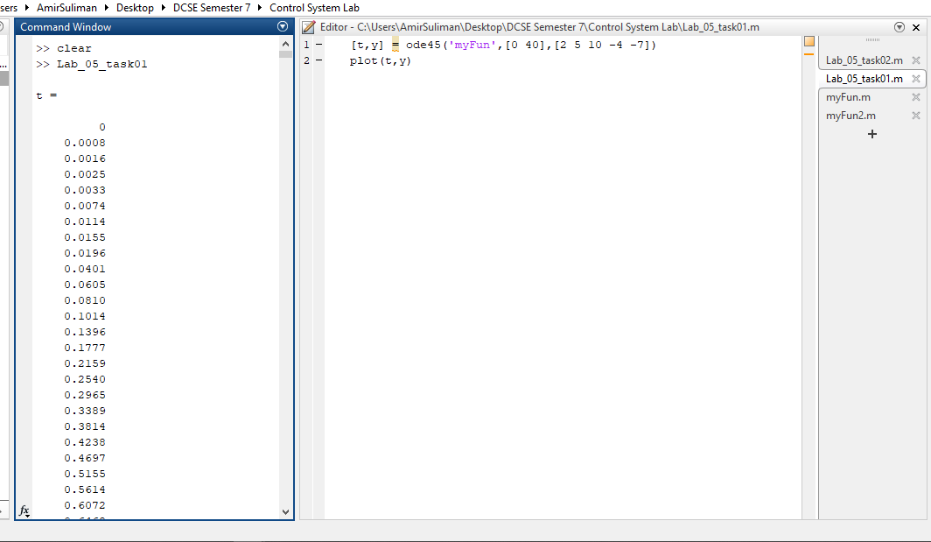

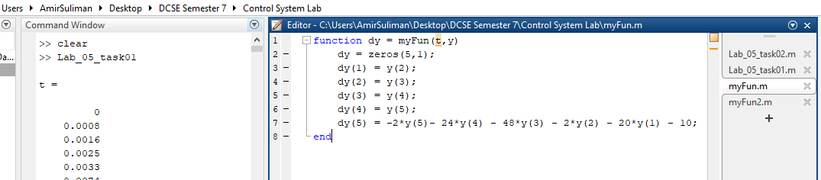

**Output:**

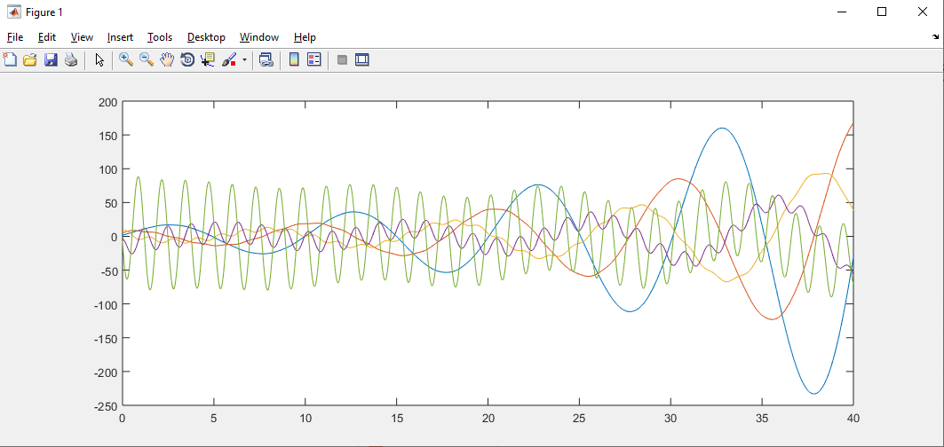

**Task 02:**

**Code:**

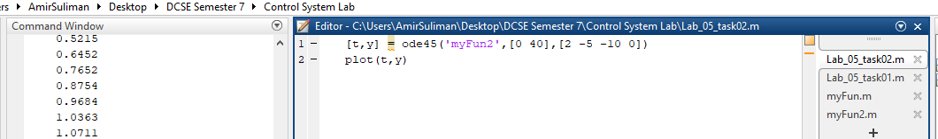

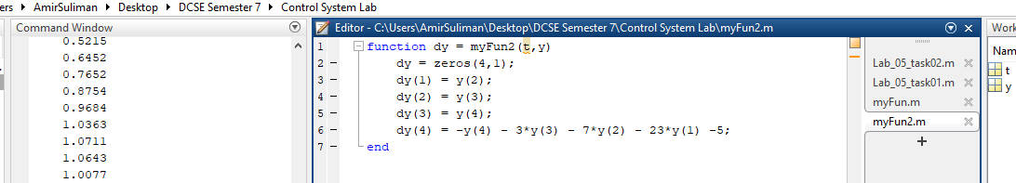

**Output:**

